All Staff Training
Author | admin
Date | 2022-03-16 11:10:12
Categories | All Staff Training

All Staff Awareness Products
To support the embedding of the Joint Doctrine, JESIP has produced an e-learning package. This package is suitable for ALL responders, from ALL responder organisations.
It is recommended that responder organisations upload the SCORM files available below to their own Learning Management System which will enable staff learning completion records.
The website version is available to all but will not offer the function of maintaining staff learning records.

E-Learning Package
Please check whether your service have made this package available via your organisation's e-learning platform before completing remotely.
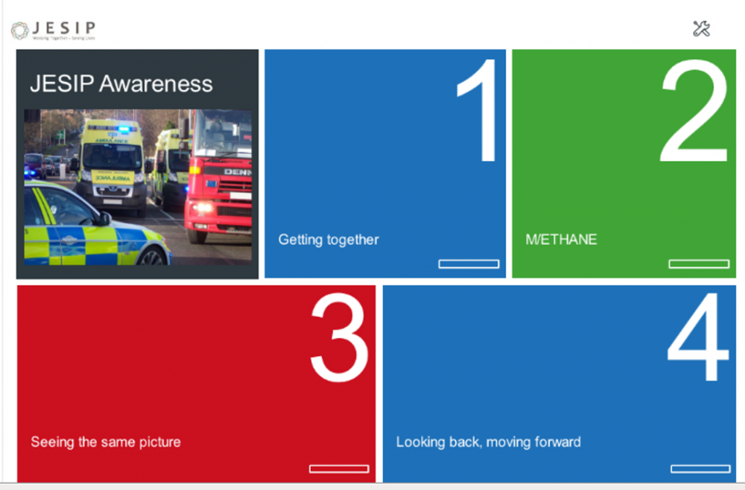
Click the above image to access the Elearning package.
Click here to download the Certificate of Completion.
Below are the downloadable versions that have been created to run on organisation's e-learning platforms:
- All Staff Awareness - SCORM 1.2 2021 Update
- All Staff Awareness - SCORM 2004 2021 Update

Classroom Products
Below are some classroom products that can be used as an alternative to elearning completion.
- Classroom Version - Quiz Questions
- Classroom Version PowerPoint Slides
- Classroom Version - Slides Handout
- Classroom Version - Slides with Trainer notes

Metadata
classic-editor-remember | block-editor
header_slider
section_bottom | [section-appandnews]
custom_css
custom_js
backup_field

