Arrangements for joint working (Joint Decision Model)
Author | admin
Date | 2022-03-15 15:38:43
Categories | Joint Doctrine Sections

8.0 Arrangements for Joint Working

Decision making in incident management follows a general pattern of:
- Working out what’s going on (situation),
- Establishing what you need to achieve (direction)
- Deciding what to do about it (action), all informed by a statement and understanding of overarching values and purpose.

8.1 Joint Decision Model

One of the difficulties facing commanders from different responder agencies is how to bring together the available information, reconcile potentially differing priorities and then make effective decisions together.
The Joint Decision Model (JDM), shown below, was developed to resolve this issue.
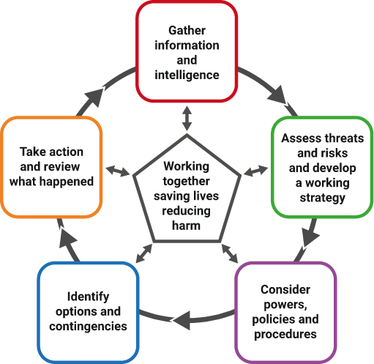
Responder agencies may use various supporting processes and sources to provide commanders with information, including information on any planned intentions, to commanders. This supports joint decision making.
All joint decisions, and the rationale behind them, should be recorded in a ‘joint decision log’.
When using the joint decision model, the first priority is to gather and assess information and intelligence.
Responders should work together to build shared situational awareness, recognising that this requires continuous effort as the situation, and responders’ understanding, will change over time.
Understanding the risks is vital in establishing shared situational awareness, as it enables responders to answer the three fundamental questions of ‘what, so what and what might?’
Once shared situation awareness is established, the preferred ‘end state’ should be agreed as the central part of a joint working strategy. A working strategy should set out what a team is trying to achieve, and how they are going to achieve it.
If a strategic co-ordinating group is convened, they will agree and share the joint strategy for the multi-agency response. The strategic command teams from each agency should then review and amend their single-agency strategy to be consistent with the joint strategy and support them in achieving the jointly defined end state, or overarching aim.
Deciding how all agencies will work towards the preferred end state reflects the available capabilities, powers, policies and procedures (means) and the arising options, constraints and contingencies (ways). Ways and means are intimately related – some options will not be viable because they can’t be implemented, or they may be technically and logistically feasible, but illegal or ethically indefensible.
The joint decision model helps commanders explore these considerations and sets out the various stages of reaching joint decisions. One of the guiding principles of the joint decision model is that decision makers use their professional judgement and experience in deciding any additional questions to ask and considerations to take into account, so that they can reach a jointly agreed decision.
Commanders should be free to interpret the joint decision model for themselves, reasonably and according to the circumstances they face at any given time. Achieving desired outcomes should always come before strict adherence to the stepped process outlined in the joint decision model, particularly in time sensitive situations.
A detailed and well-practised understanding of the joint decision model will help commanders to think clearly and in an ordered way when under stress. The joint decision model can be used for both ‘rapid onset’ and ‘rising tide’ emergencies.
The following sections summarise the questions and considerations that commanders should think about when they use the joint decision model. Click here for more information on the JDM.

8.1.1.Working Together – Saving Lives, Reducing Harm
The pentagon at the centre of the joint decision model reminds commanders that all joint decisions should be made with reference to the overarching or primary aim of any response to an emergency – to save lives and reduce harm.
This should be the most important consideration, throughout the decision making process.

8.1.2.Gather information and intelligence
This stage involves gathering and sharing information and intelligence to establish shared situational awareness.
At any incident, no single responder agency can appreciate all the relevant dimensions of an emergency straight away.
A deeper and wider understanding will only come from meaningful communication between the emergency services and other responder agencies. Commanders cannot assume others will see things, or say things, in the same way.
There may need to be a sustained effort to reach a common view and understanding of events, risks and their implications,
Decision making in the context of an emergency, including decisions on sharing information, does not remove the statutory obligations of agencies or individuals, but it is recognised that such decisions are made with an overriding priority of saving lives and reducing harm.
Personal data, including sensitive personal data (such as police intelligence), must be carefully considered before it is shared across agencies. The joint decision model can be used as a tool to guide decision making on what information to release, and who can receive it.
M/ETHANE is a structured and consistent method for responder agencies to collate and pass on information about an incident.

8.1.3.Assess risks, develop a working strategy
Commanders jointly assess risk to achieve a common understanding of threats and hazards, and the likelihood of them being realised. This informs decisions on deployments and the required risk control measures.
A key task for commanders is to build and maintain a common understanding of the full range of risks. They should consider how risks may increase, reduce or be controlled by any decisions made and subsequent actions taken. At any incident, each responder agency will have a unique insight into those risks.
By sharing what they know commanders can establish a common understanding. Commanders can then make informed decisions on deployments and the risk control measures required. Time critical tasks should not be delayed by this process.
The risk control measures to be employed by individual services must also be understood by other responder agencies, to ensure any potential unintended consequences are identified before activity commences. This increases the operational effectiveness and efficiency of the response as well as the probability of a successful incident resolution.
The working strategy should not be confused with the strategy for the incident provided by the strategic commanders or strategic co-ordinating group. This strategy will generally be issued some time into the incident response and almost certainly after the operational or tactical levels of command have been established.
The working strategy is the action plan that commanders develop and agree together. They put the action plan in place to address the immediate situation and the risks that they are faced with to save lives and reduce harm.
It is rare for a complete or perfect picture to exist for a rapid onset incident. The working strategy should therefore be based on the information available at the time.
When developing a working strategy, consider:
- Sharing single service risk assessments
- Recording and agreeing the joint assessment of risk, in an agreed format
When developing a working strategy, commanders should consider these questions:
- What: Are the aims and objectives?
- Who by: Police, fire and rescue services, the ambulance service and other organisations?
- When: Timescales, deadlines and milestones?
- Where: What locations?
- Why: What is the rationale? Is it consistent with the overall strategic aims and objectives?
- How: Will these tasks be achieved?
For an effective integrated multi-agency operational response plan, objectives and priorities must be agreed jointly. Each agency will then prioritise their plans and activity.
The following key steps should be undertaken:
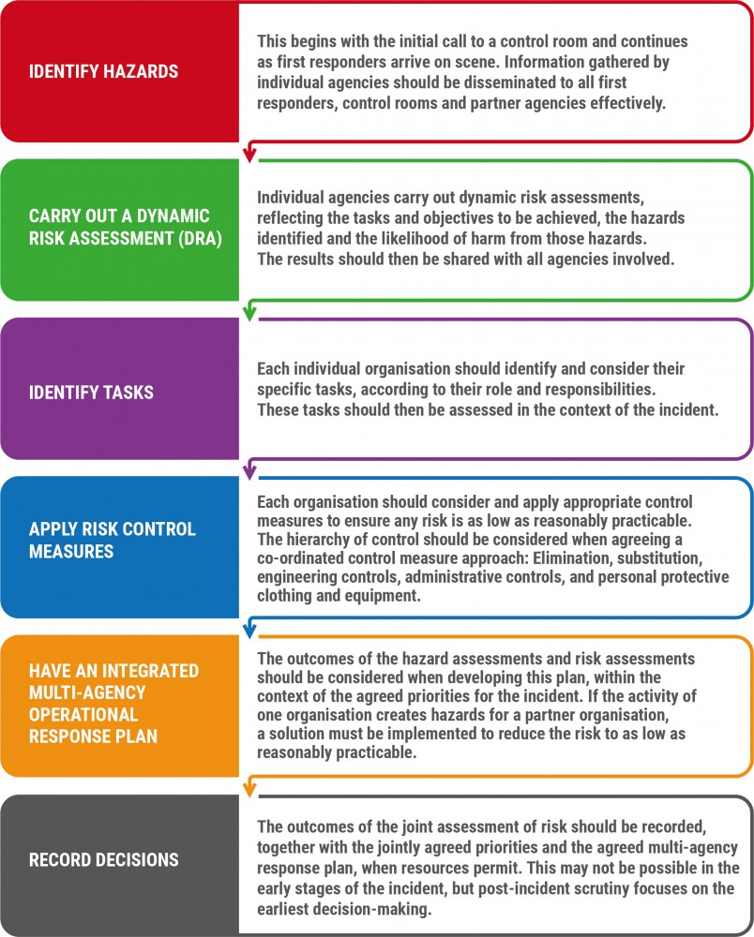
This stage relates to any relevant laws, procedures or policies that may impact on the response plan and the capabilities available to be deployed.8.1.4.Consider powers, policies and procedures
Decision making in an emergency will focus on achieving the desired end state. Various constraints and considerations will shape how this is achieved.
Power, policies and procedures may affect how individual agencies operate and co-operate to achieve the agreed aims and objectives.
In a joint response, a common understanding of any relevant powers, policies, capabilities and procedures is essential so that the activities of one responder agency complement rather than compromise the approach of other responder agencies.

8.1.5.Identify options and contingencies
There will almost always be more than one way to achieve the desired end state. Commanders should work together to evaluate the range of options and contingencies rigorously.
Potential options or courses of action should be evaluated, considering:
- Suitability Does it fit with the strategic direction?
- Feasibility Can it be done with the available resources?
- Acceptability Is it legal, morally defensible and justifiable?
Whichever options are chosen, it is essential that commanders are clear on what they need to carry out. Procedures for communicating any decision to defer, abort or initiate a specific tactic should also be clearly agreed.
Contingencies relate to events that may occur and the arrangements that will be put in place if they do occur. For example, strong evidence may suggest that an emergency is being successfully managed and the impacts safely controlled, but there remains a likelihood that the situation could deteriorate and have a significant impact. It is not good enough to ‘hope for the best’ and a contingency may include defining the measures to be taken if the situation deteriorates.

8.1.6.Decision controls
As part of the decision making process, decision makers should use decision controls to ensure that the proposed action is the most appropriate.
Decision controls support and validate the decision making process. They encourage reflection and set out a series of points to consider before making a decision:
Note that points (a) to (d) are intended to structure a joint consideration of the issues, with (e) suggesting some considerations for individual reflection.
Once the decision makers are satisfied, collectively and individually, that the decision controls validate the proposed actions, then these actions should be implemented.
As the joint decision model is a continuous loop, it is essential that the results of these actions are fed back into the first box – ‘Gather and share information and intelligence’ – which sets out the need to establish and sustain shared situational awareness. This will, in turn, shape any change in direction or risk assessment as the cycle continues.
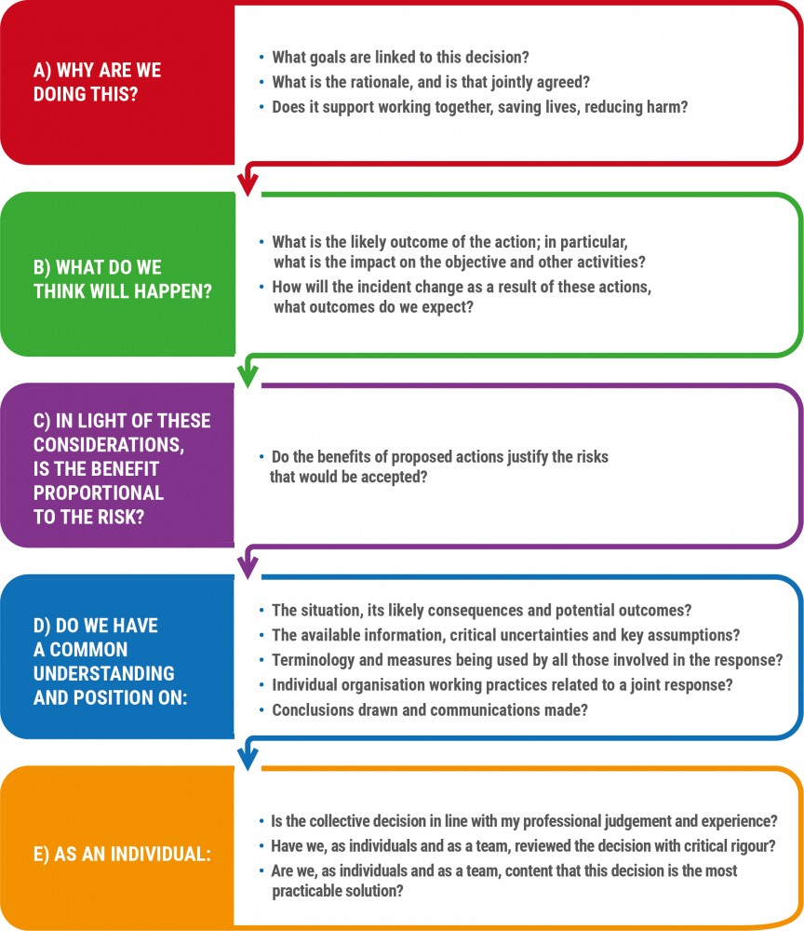

8.1.7.Briefing
Once commanders have made decisions and decided on actions, information must be relayed in a structured way that can be easily understood by those who will carry out actions or support activities. This is
commonly known as briefing.
In the initial phases of an incident, the joint decision model may be used to structure a briefing. As incidents develop past the initial phases or if they are protracted and require a hand over between commanders and responders, then a more detailed briefing tool should be used. The mnemonic ‘IIMARCH’ is a commonly used briefing tool.
Using the IIMARCH headings shown below as a guide, information can be briefed in appropriate detail:
- Information
- Intent
- Method
- Administration
- Risk assessment
- Communications
- Humanitarian issues
Information on IIMARCH and its use as a briefing tool can be found here (link to Supporting document 7.

8.1.8.Take action and review what happened
Building shared situational awareness, setting direction, evaluating options and making decisions all lead to taking the actions that are judged to be the most effective and efficient in resolving an emergency and returning to a new normality.
Actions must be reviewed. As information changes during the response, commanders should use the joint decision model to inform their decision making until the incident is resolved.

Metadata
classic-editor-remember | block-editor
header_slider
section_bottom | [section-appandnews]
custom_css | strong { font-weight: bold; }
custom_js
backup_field

