Commander Identification Tabards
Author | admin
Date | 2022-03-16 09:34:09
Categories

Fire
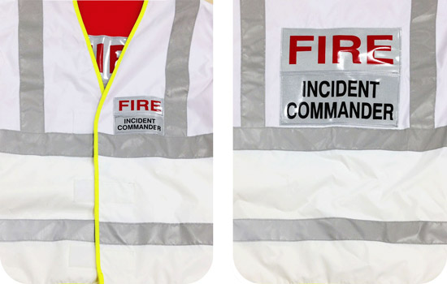
The Fire & Rescue Service 'Incident Commander' on the scene, irrespective whether an Operational or Tactical commander, will wear this tabard

Police
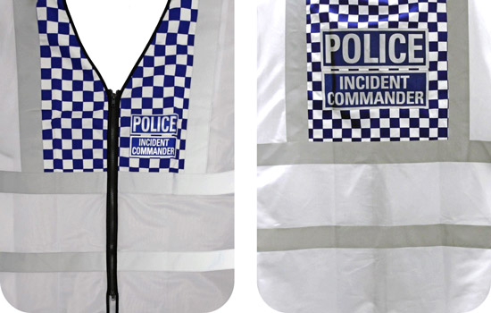
The Police Commander on the scene will wear this tabard.

Ambulance
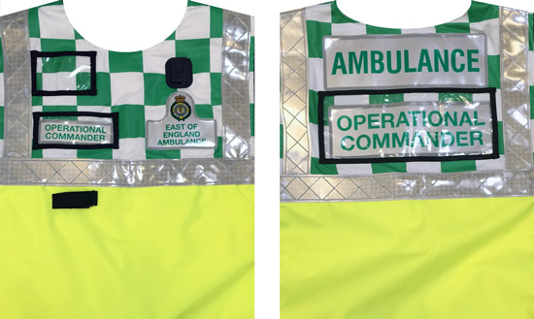
The Operational Commander would wear this tabard.

Ambulance
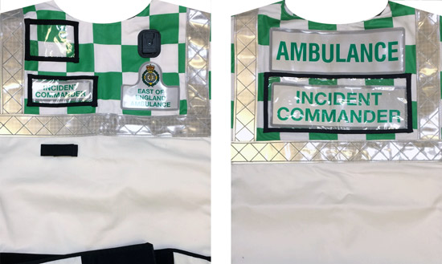
The Tactical Commander will wear this tabard (referred to as the Ambulance Incident Commander).

HM Coastguard
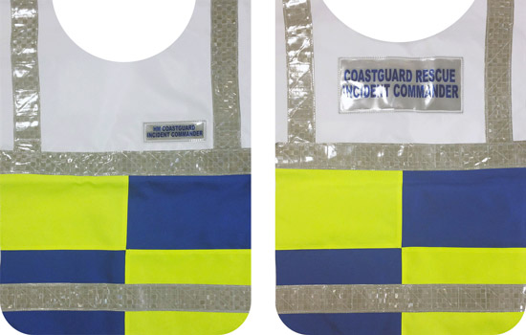
The incident commander tabard would be worn by the HM Coastguard operational commander.

HM Coastguard
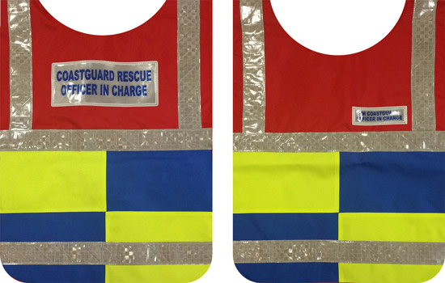
The officer-in-charge tabard would be worn by the person in charge of the HM Coastguard team deployed.

Miscellaneous Responder Tabard – Advisory
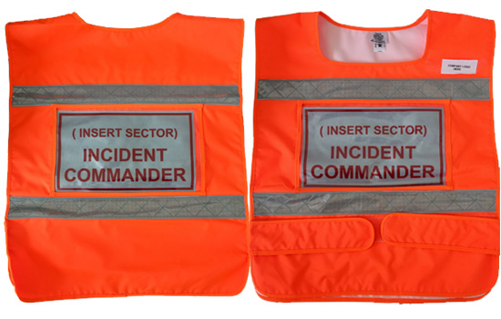
The commander from any emergency responder organisation at the scene of a multi-agency incident could wear a similar design tabard. For further information please click here.

Metadata
classic-editor-remember | block-editor
header_slider
section_bottom
custom_css | @media (max-width: 979px){ body:not(.home) .section_content img { width: 100vw; } body:not(.home) .section_content .wp-block-column { margin-bottom: var(--margindesktop); } } @media (max-width: 767px){ body.single .section_content .wp-block-columns { margin-bottom: unset; margin-top: unset; } }
custom_js
backup_field

