Doctrine
Author | admin
Date | 2022-03-15 11:53:14
Categories
As with any operational organisation, policy defines what needs to be done.
For JESIP the Joint Doctrine is the policy which applies to emergency responder interoperability and is the foundation of JESIP. It sets out what is expected of responder agencies as they work together responding to emergencies.
This area of our work aims to ensure that all national and local policies, procedures and guidance that relate to multi-agency operational response are aligned (and remain aligned) to JESIP. We are also making sure that arrangements are in place to ensure any newly developed policy or guidance aligns to JESIP.
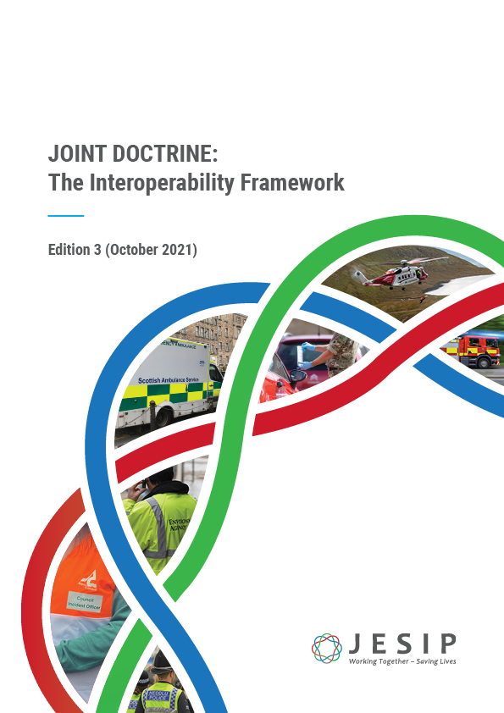

Related download

Joint Doctrine Guide
Last updated: Oct 2021
The Joint Doctrine – Edition Three has now been published. It continues to provide a common way of ...
View download

Current Priorities
- Complete the review of the Joint Doctrine - now complete
- Method for regularly assessing progress with local embedding of JESIP - Self-Assessment Survey
- Ensuring all relevant single service doctrine is aligned to JESIP
- Ensuring all relevant national doctrine (including specialist doctrine such as MTFA and CBRN) is aligned to JESIP

Who leads this workstream?
Carl Daniels – the JESIP Deputy Senior Responsible Officer and Ambulance Senior User leads on this JESIP workstream.

Metadata
classic-editor-remember | block-editor
header_slider
section_bottom | [section-appandnews]
custom_css
custom_js
backup_field

