Documents of Interest
Author | admin
Date | 2022-03-23 10:32:49
Categories
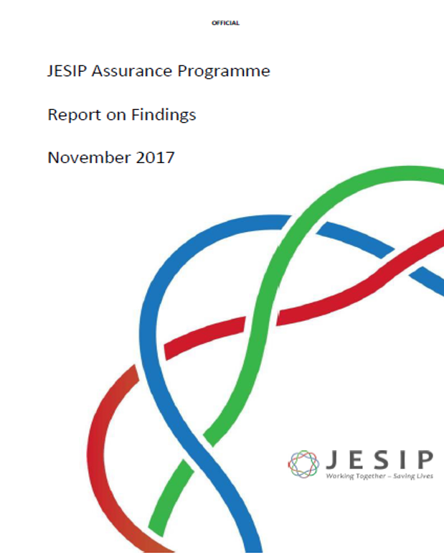

JESIP Assurance Visits – Findings Report 2017
Download document
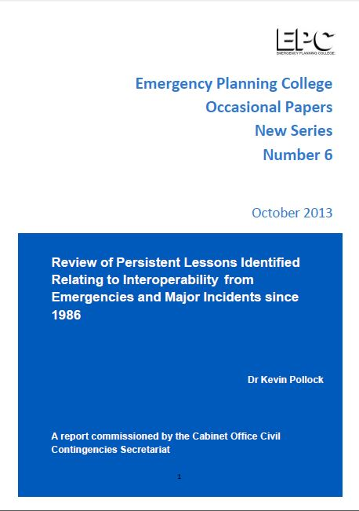

The Pollock Report
Download document
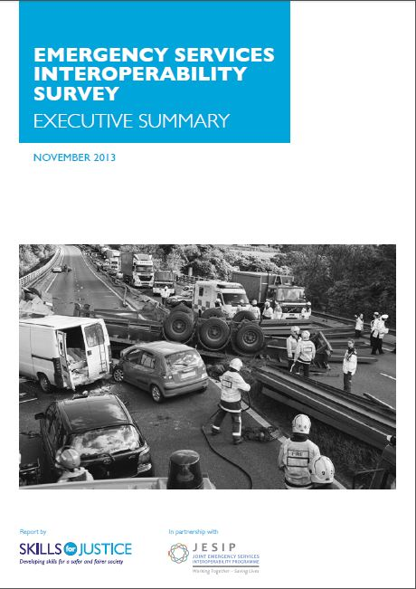

Workforce Survey 1 – Executive Summary 2013
Download document
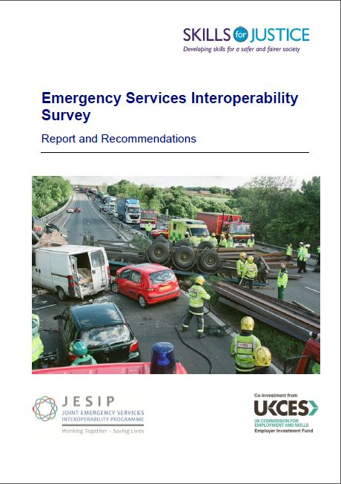

Workforce Survey 1 – Full Report 2013
Download document
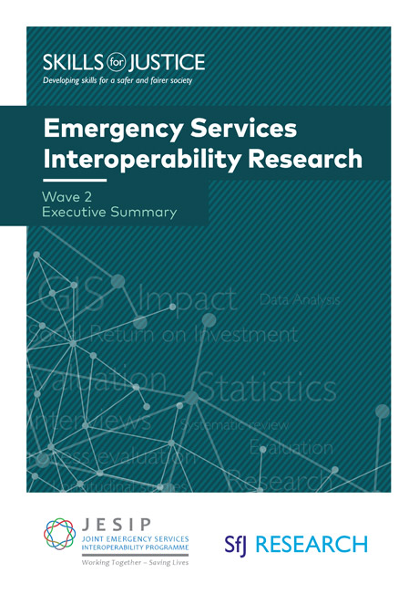

Workforce Survey 2 – Executive Summary
Download document
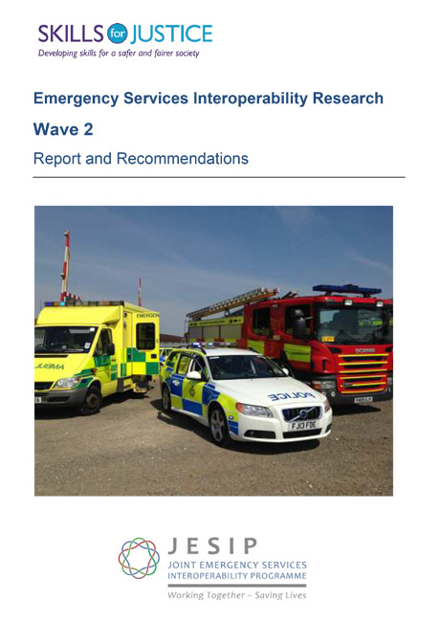

Workforce Survey 2 – Full Report 2013
Download document
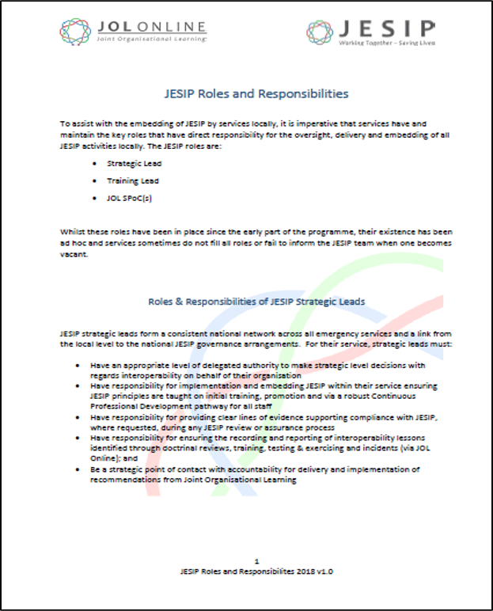

JESIP Roles & Responsibilities in Services
Download document
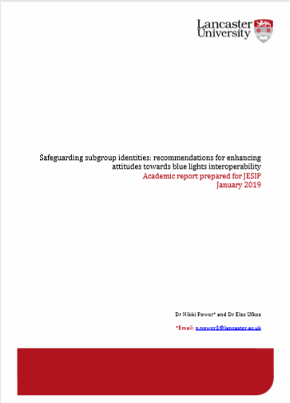

Safeguarding subgroup identities
Download document
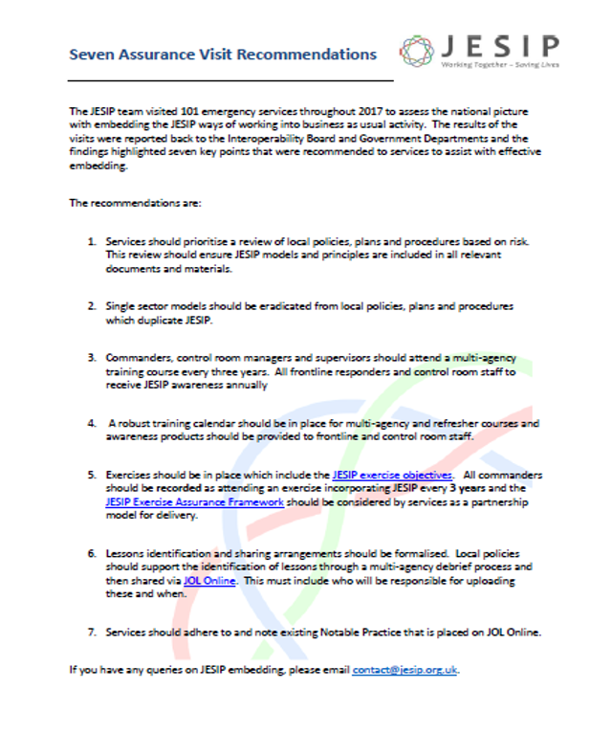

JESIP 7 Assurance Visit Recommendations
Download document

Metadata
classic-editor-remember | classic-editor
header_slider
section_bottom | [section-appandnews]
custom_css | .gridcontainer { display: grid; grid-template-columns: repeat(3, 1fr); gap: 0; grid-gap: calc( var(--margindesktop) / 2); margin-bottom: calc( var(--margindesktop) / 2); } @media (max-width: 979px) { .gridcontainer { grid-template-columns: repeat(2, 1fr); grid-gap: calc( var(--margindesktop) / 2); margin-bottom: calc( var(--margindesktop) / 2); } body .section_cover_download.modegrid .section_container { min-height: 62.5vw; } } @media (max-width: 767px) { .gridcontainer { grid-template-columns: repeat(2, 1fr); grid-gap: calc( var(--margindesktop) / 1); margin-bottom: calc( var(--margindesktop) / 1); } body .section_cover_download.modegrid .section_container { min-height: 75vw; } } @media (max-width: 625px) { .gridcontainer { grid-template-columns: repeat(1, 1fr); grid-gap: calc( var(--margindesktop) / 1); margin-bottom: calc( var(--margindesktop) / 1); } body .section_cover_download.modegrid .section_container { min-height: unset; } }
custom_js
backup_field

