Governance Structure
Author | admin
Date | 2022-03-15 10:11:15
Categories
JESIP is provided with governance through the JESIP Interoperability Board which meets quarterly. This is a chief officer level board, supported by cross-government departments at the director level. Further insight is provided through a Ministerial Board.

Meet the Board

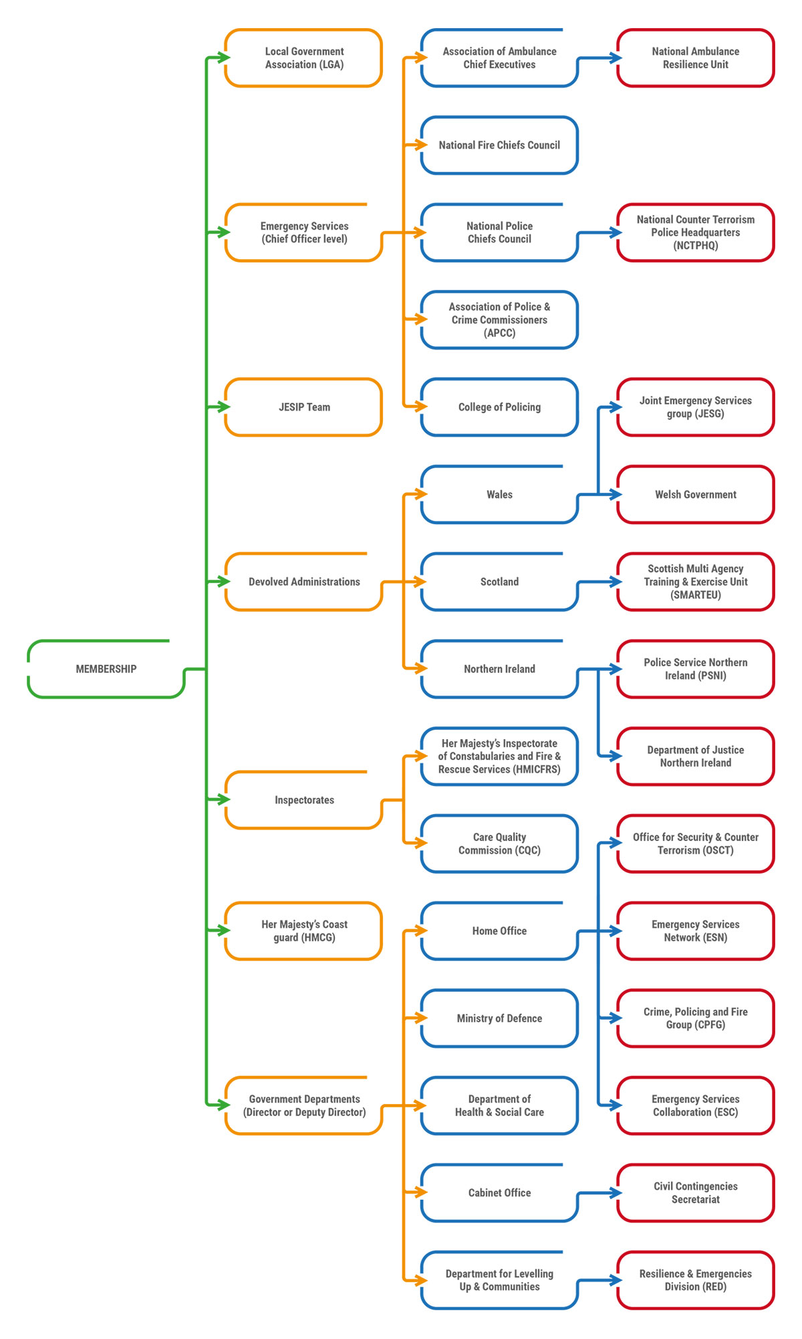

Metadata
classic-editor-remember | block-editor
header_slider
section_bottom | [section-appandnews]
custom_css | body img.section_cover_download_image { max-width: 100%!important; }
custom_js
backup_field

