Incident Reports and Inquiries
Author | admin
Date | 2022-03-23 10:36:17
Categories
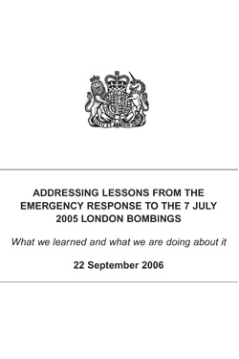

Addressing Lessons from London 7th July 2005 Bombings
Download document
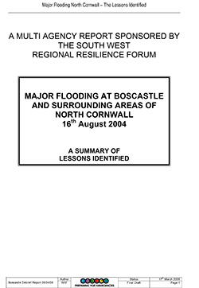

Boscastle Floods Debrief Report
Download document
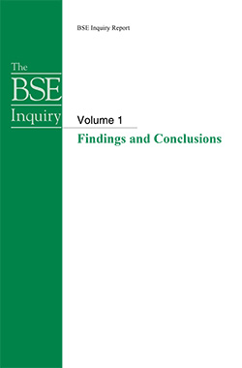

BSE Outbreak Conclusion
Download document
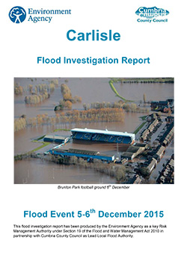

Carlisle Flood Report
Download document

BSE Outbreak Conclusion
Download document

Carlisle Flood Report
Download document
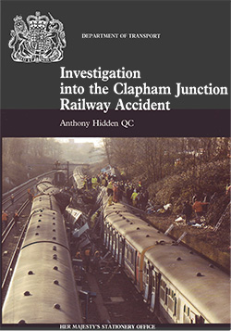

Clapham Rail Crash
Download document
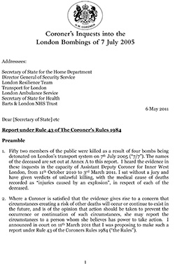

Coroners Inquest in to London Bombings
Download document
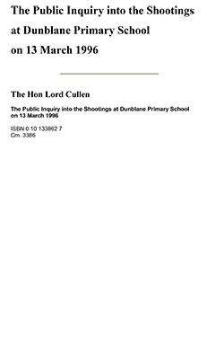

Dunblane Shootings Public Inquiry Report
Download document
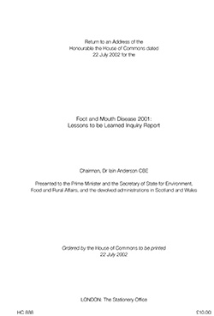

Foot and Mouth Disease 2001 Inquiry Report
Download document
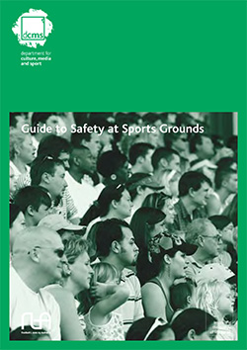

Guide to Safety at Sports Grounds
Download document
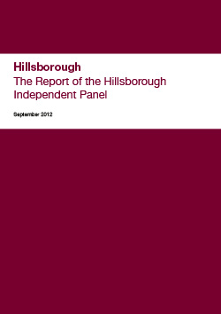

Hillsborough Report 2012
Download document
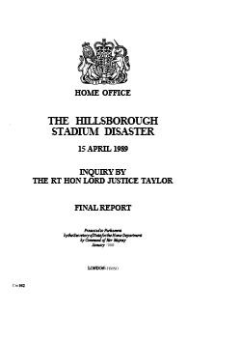

Hillsborough Stadium Disaster final report
Download document
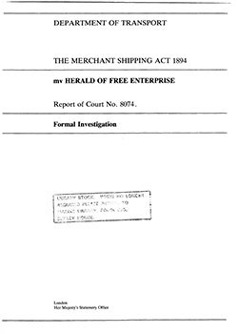

Herald of Free Enterprise Report
Download document
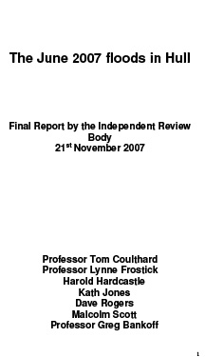

Hull Floods June 2007 Report
Download document
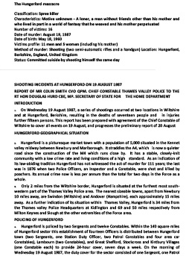

Hungerford Shootings
Download document
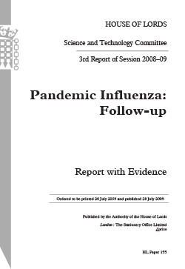

Influenza Pandemic
Download document
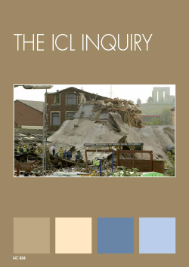

ICL Factory Explosion
Download document
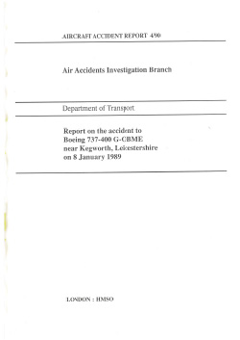

Kegworth Aircrash
Download document
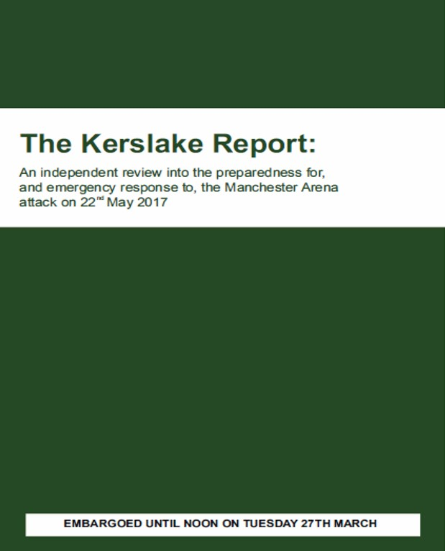

The Kerslake Report 2018
Download document
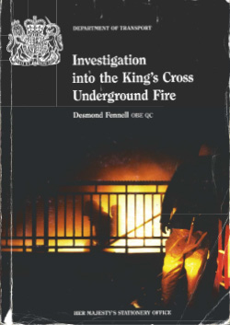

Kings Cross Underground Fire – Fennell Report
Download document
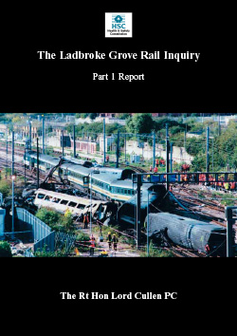

Ladbroke Grove Rail Inquiry Report Part 1
Download document
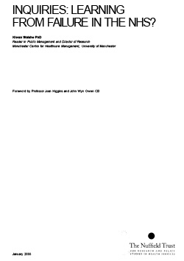

Learning from Failures in the NHS
Download document
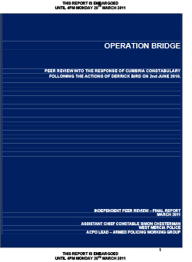

Operation Bridge Peer Review – Derrick Bird Shootings
Download document
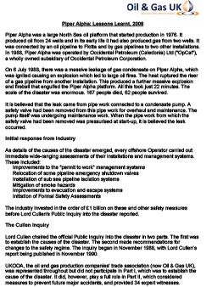

Piper Alpha Explosion
Download document

Learning from Failures in the NHS
Download document
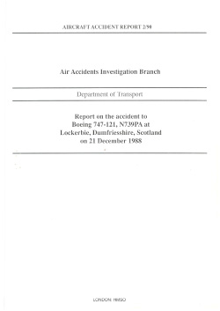

Lockerbie Aircraft Accident Report
Download document
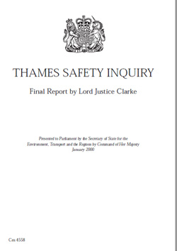

Marchioness-Bowbelle Incident – Thames Safety Inquiry
Download document

Lockerbie Aircraft Accident Report
Download document
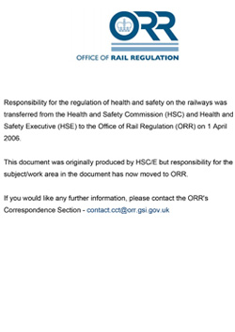

Ladbroke Grove Rail Inquiry Report Part 2
Download document
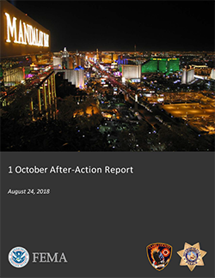

Las Vegas Shooter Incident October 2017
Download document
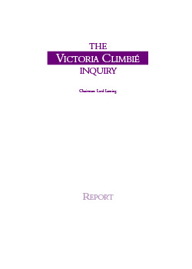

The Victoria Climbie Inquiry
Download document
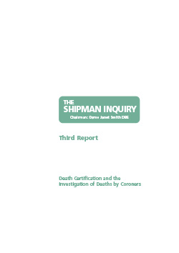

The Shipman Inquiry
Download document
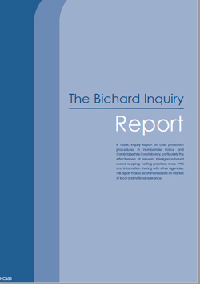

The Bichard Inquiry Report
Download document
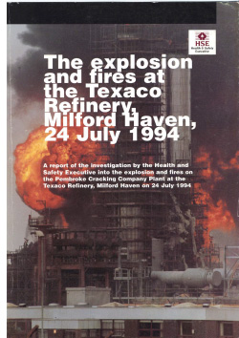

Texaco Refinery Explosion
Download document
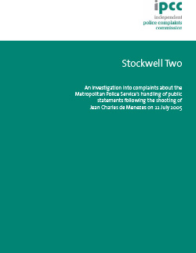

Stockwell Shooting Report (Jean Charles De Menzes) Part 2
Download document
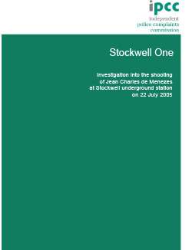

Stockwell Shooting Report (Jean Charles De Menzes) Part 1
Download document
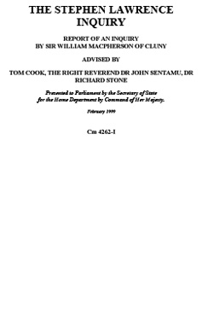

Stephen Lawrence Inquiry
Download document
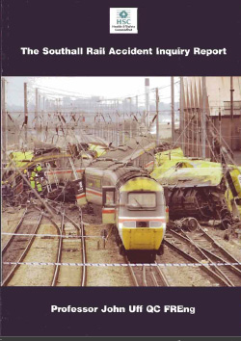

Southall Rail Crash
Download document
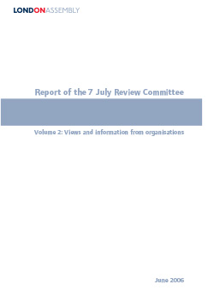

Report of the 7 July Review Committee
Download document


Pitt Review (UK Floods)
Download document

Piper Alpha Explosion
Download document

Operation Bridge Peer Review – Derrick Bird Shootings
Download document

Metadata
classic-editor-remember | classic-editor
header_slider
section_bottom | [section-appandnews]
custom_css | .gridcontainer { display: grid; grid-template-columns: repeat(3, 1fr); gap: 0; grid-gap: calc( var(--margindesktop) / 2); margin-bottom: calc( var(--margindesktop) / 2); } @media (max-width: 979px) { .gridcontainer { grid-template-columns: repeat(2, 1fr); grid-gap: calc( var(--margindesktop) / 2); margin-bottom: calc( var(--margindesktop) / 2); } body .section_cover_download.modegrid .section_container { min-height: 62.5vw; } } @media (max-width: 767px) { .gridcontainer { grid-template-columns: repeat(2, 1fr); grid-gap: calc( var(--margindesktop) / 1); margin-bottom: calc( var(--margindesktop) / 1); } body .section_cover_download.modegrid .section_container { min-height: 75vw; } } @media (max-width: 625px) { .gridcontainer { grid-template-columns: repeat(1, 1fr); grid-gap: calc( var(--margindesktop) / 1); margin-bottom: calc( var(--margindesktop) / 1); } body .section_cover_download.modegrid .section_container { min-height: unset; } }
custom_js
backup_field

