JESIP Graphics
Author | admin
Date | 2022-03-23 10:41:06
Categories

Graphics
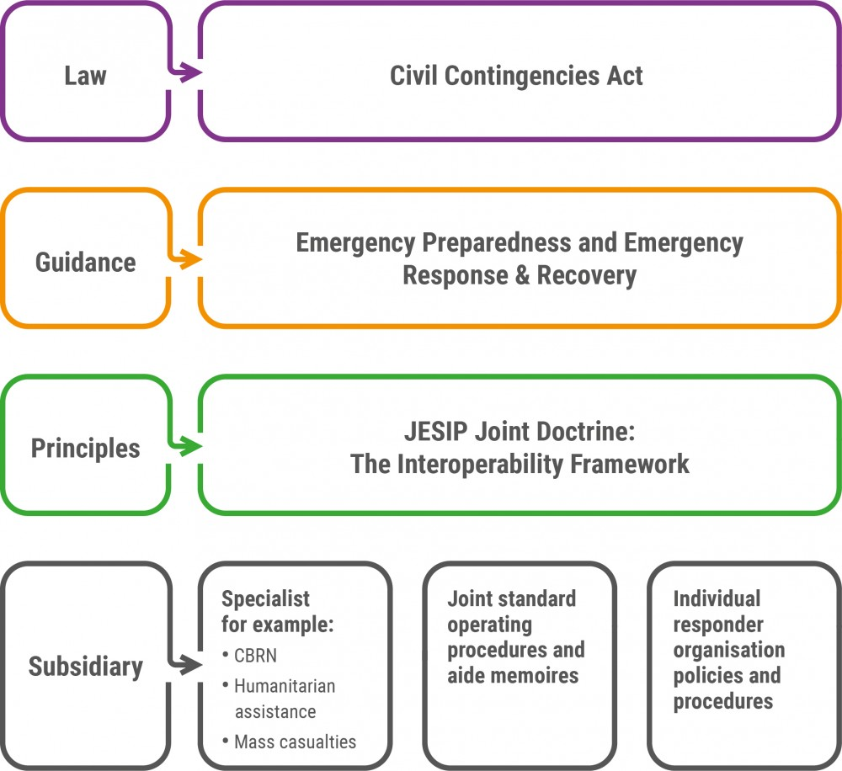

Position of JESIP
Download document
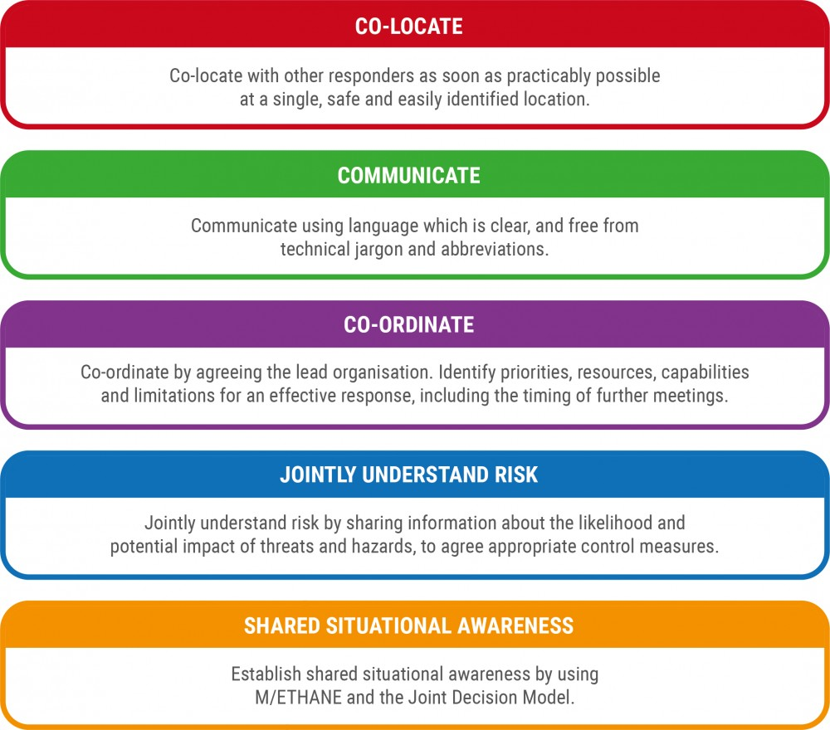

Principles
Download document
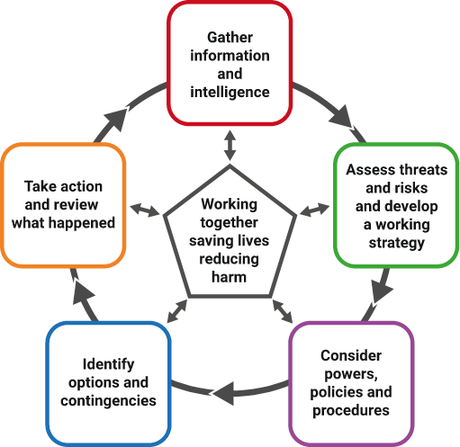

The Joint Decision Model (JDM)
Download document
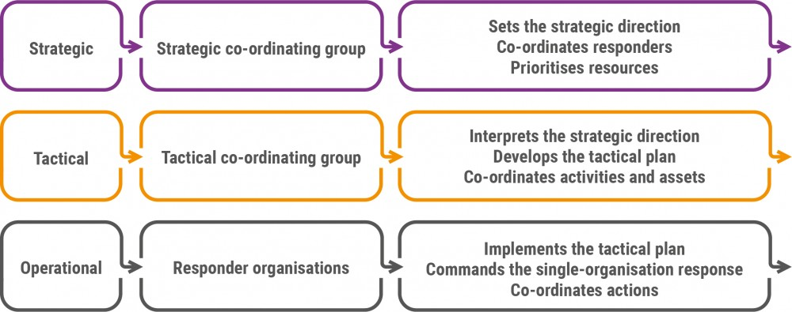

Command Levels
Download document
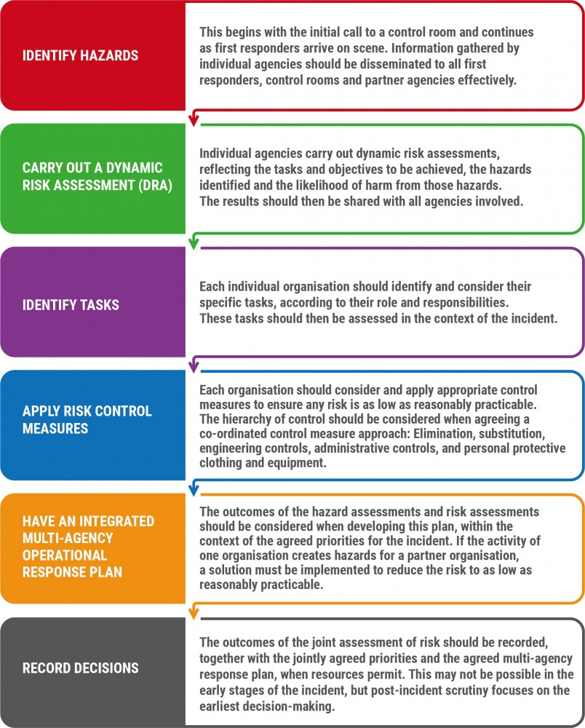

Risk Assessments
Download document
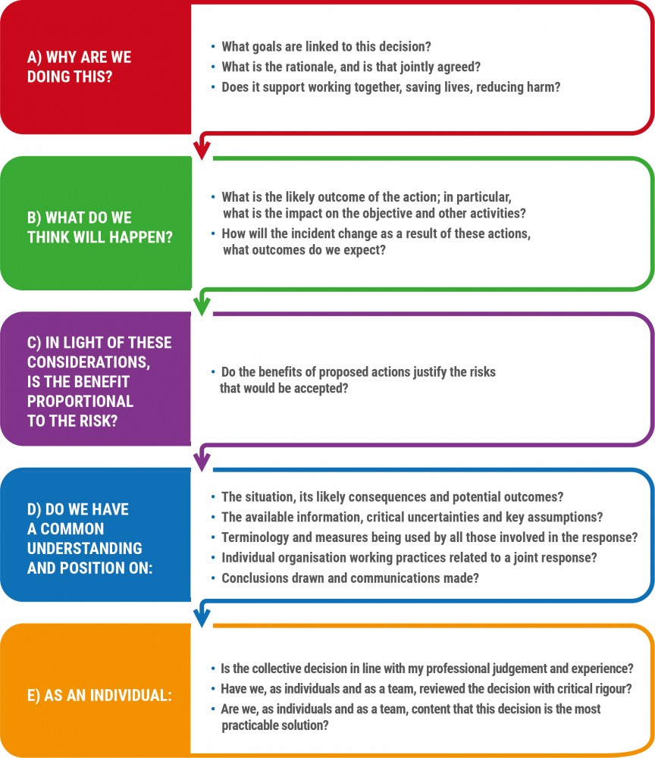

Decision Controls
Download document
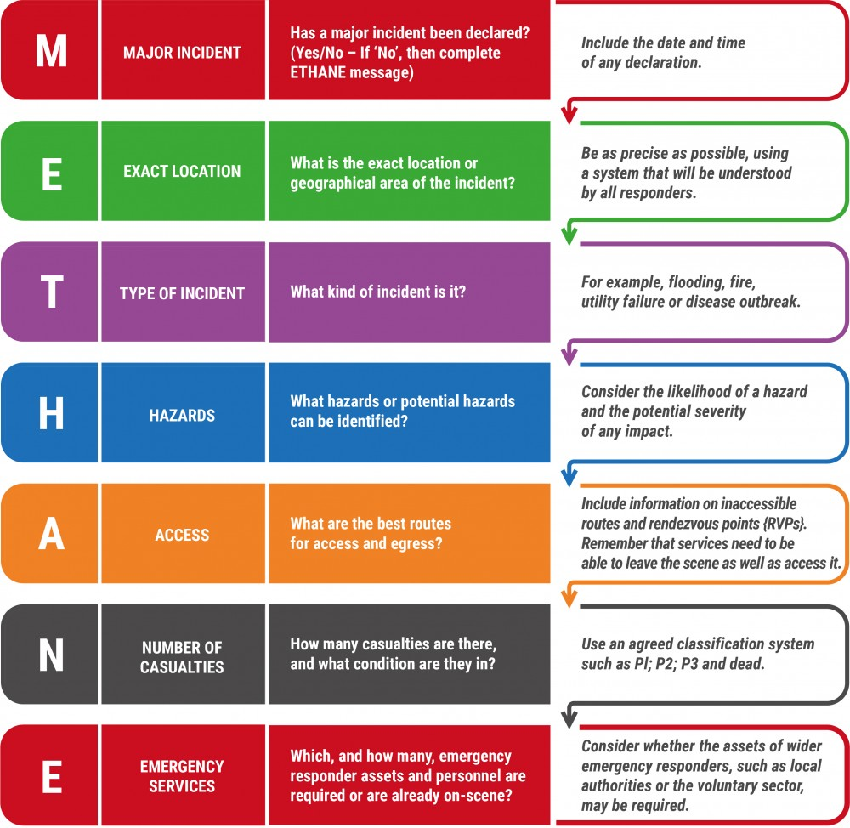

M/ETHANE full version
Download document
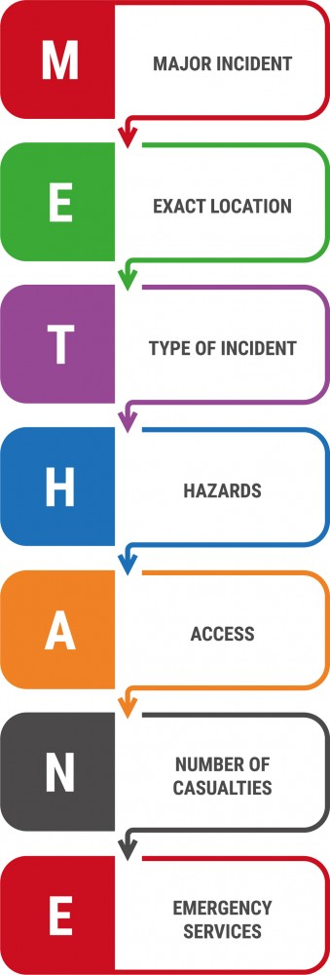

M/ETHANE 2 Columns
Download document
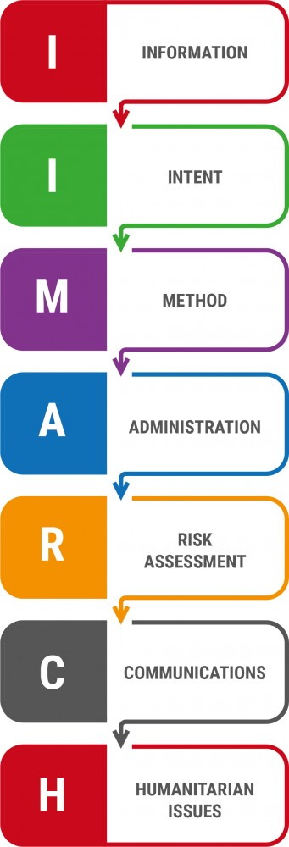

IIMARCH
Download document
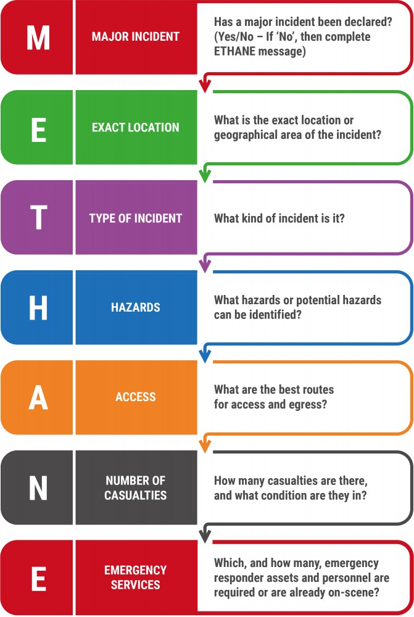

M/ETHANE 3 Columns
Download document
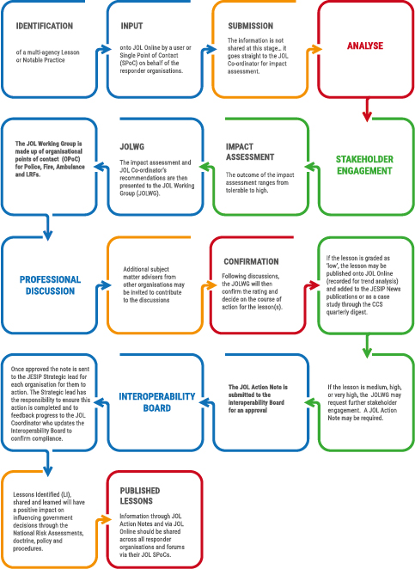

JOL Process
Download document
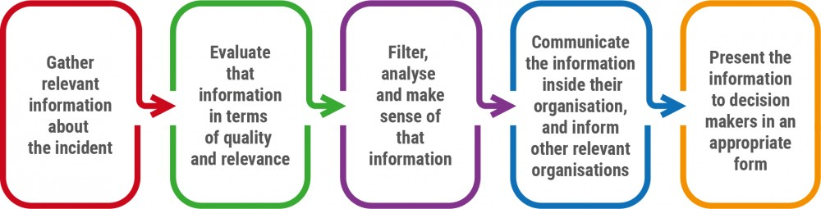

Information Processing and Use
Download document
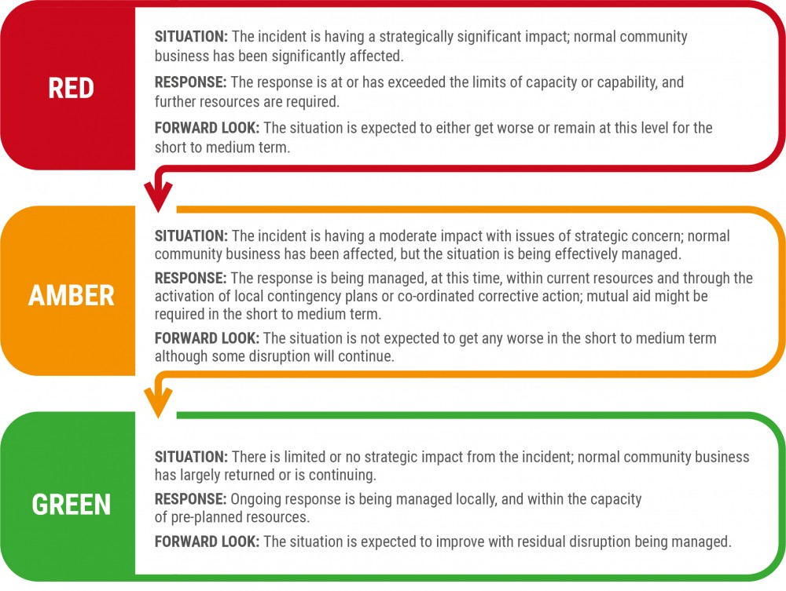

Multi-Agency Information Cell (MAIC) RAG Status
Download document
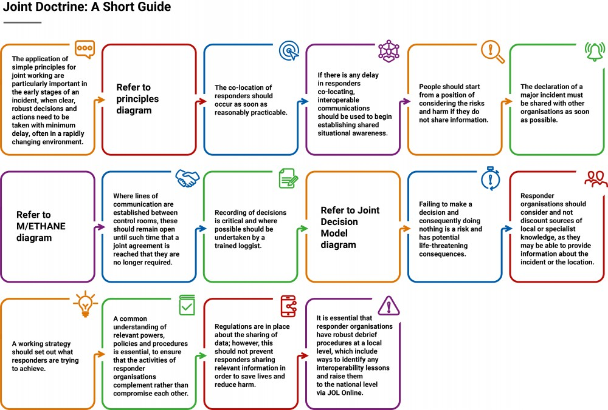

Joint Doctrine Short Guide
Download document
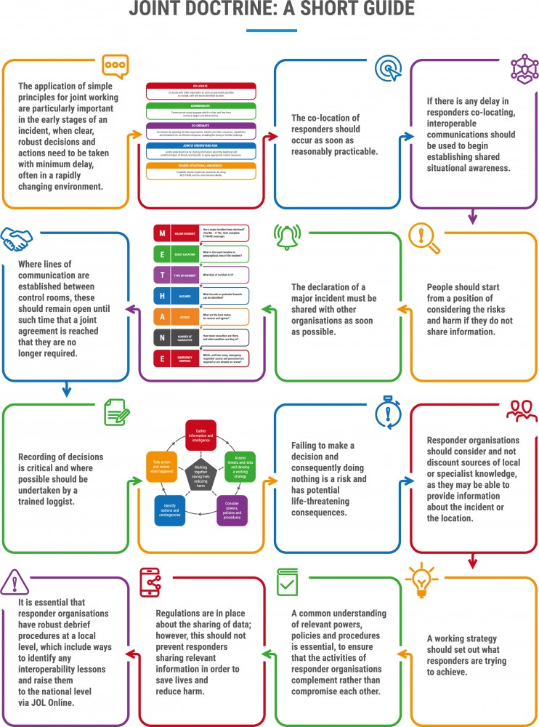

Joint Doctrine Short Guide Portrait
Download document

Jesip Logos


Jesip Logo Portrait
Download document


Jesip Logo – WT-SL
Download document


Jesip JOL Online Logo
Download document

Metadata
classic-editor-remember | classic-editor
header_slider
section_bottom | [section-appandnews]
custom_css | .gridcontainer { display: grid; grid-template-columns: repeat(3, 1fr); gap: 0; grid-gap: calc( var(--margindesktop) / 2); margin-bottom: calc( var(--margindesktop) / 2); } @media (max-width: 979px) { .gridcontainer { grid-template-columns: repeat(2, 1fr); grid-gap: calc( var(--margindesktop) / 2); margin-bottom: calc( var(--margindesktop) / 2); } body .section_cover_download.modegrid .section_container { min-height: 62.5vw; } } @media (max-width: 767px) { .gridcontainer { grid-template-columns: repeat(2, 1fr); grid-gap: calc( var(--margindesktop) / 1); margin-bottom: calc( var(--margindesktop) / 1); } body .section_cover_download.modegrid .section_container { min-height: 75vw; } } @media (max-width: 625px) { .gridcontainer { grid-template-columns: repeat(1, 1fr); grid-gap: calc( var(--margindesktop) / 1); margin-bottom: calc( var(--margindesktop) / 1); } body .section_cover_download.modegrid .section_container { min-height: unset; } }
custom_js
backup_field

