Joint Organisational Learning
Author | admin
Date | 2022-03-15 11:19:04
Categories

What is Joint Organisational Learning?
To have a joint organisational learning strategy fully embedded, nationally was one of the original objectives for JESIP and is a key element of Joint Doctrine: The Interoperability Framework.
JESIP in partnership with the Civil Contingencies Secretariat (CCS) have launched new Joint Organisational Learning arrangements for emergency services and Local Resilience Forums (LRFs) in the UK called JOL Online.

JOL Online
JOL Online is a unique but simple way to capture lessons identified that may impact on multi-agency working and allow us to continually improve what we do. Lessons identified or notable practice may come from training, testing and exercising or incidents including a range of external sources.
The key to the capture of all interoperability and national capabilities lessons is through local single and multi-agency debriefs. All debriefs should have interoperability as a core theme and any lessons identified are captured in line with JOL Guidance and inputted onto JOL Online.
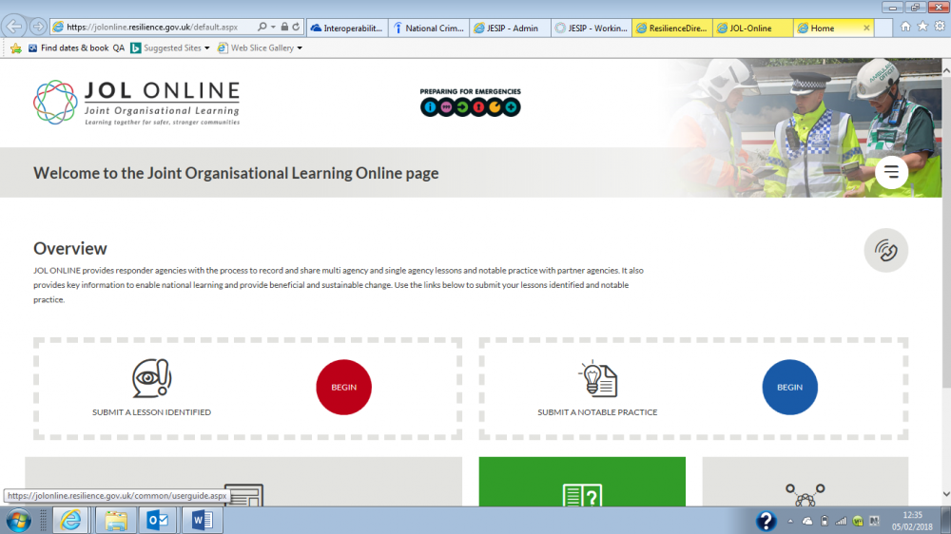

JOL Online is hosted on ResilienceDirect. It is a Cabinet Office secure system at official-sensitive government security classifications in line with and is the national repository for interoperability, national resilience lessons and notable practice across the UK.
Access to JOL Online is accessible to all Category 1 and 2 responders as well as many additional sponsored organisations. JESIP supported by a wide range of stakeholders from the emergency services, Civil Contingencies Secretariat, the military and JOL Online developers have provided initial training since September 2017 on JOL through 11 workshops across the UK and successful delivery of 2 JOL strategic seminars.
The enhanced functionality for emergency responder organisations provides them with many more facilities including the ability to identify where their respective lessons fits within any of the National Risks and where lessons or notable practice is inputted from anywhere in the UK and published they will be notified by email.
JOL Online, its supporting governance and structures now provides emergency responder agencies with a clear and standardised national process for learning and supporting beneficial and sustainable change. It improves planning and response arrangements and underpins the mantra of JOL Online - "Learning together for safer, stronger communities".
JESIP and our stakeholders will continue to work with emergency responder agencies to increase awareness and use of JOL Online.

Access to JOL Online

Current Priorities
- Raise awareness of JOL to increase lessons and notable practice which are shared and can be acted upon
- To support services in the capture of all interoperability and national capabilities lessons through their local single and multi-agency debriefs and ensure any learning with national implications is inputted onto JOL
- Provide regular updates to responder agencies on JOL activity via newsletters and quarterly lessons digest
- Provide regular updates on JOL activity and issues requiring action to the Interoperability Board including providing assurance that recommendations have been implemented

Metadata
classic-editor-remember | block-editor
header_slider
section_bottom | [section-appandnews]
custom_css | .wp-block-button__link { width: 250px; }
custom_js
backup_field

