Status of the Joint Doctrine
Author | admin
Date | 2022-03-15 12:46:31
Categories | Joint Doctrine Sections
The structure for managing the local multi-agency response to emergencies is based on the Civil Contingencies Act (2004). The act is supported by two sets of guidance: Emergency Preparedness and Emergency Response and Recovery (ERR). Emergency Preparedness deals with the pre-emergency (planning) phase. Emergency Response and Recovery (ERR) describes the multi-agency framework for responding to, and recovering from, emergencies in the UK.
Details of the operation and co-ordination of emergency response can be found in the Cabinet Office Concept of Operations and the relevant chapters of Emergency Response and Recovery.
This publication complements Emergency Response and Recovery (ERR) by focusing on the interoperability of responder organisations in the response to an incident.
Separate publications set out specialist ways of working that will apply in specific circumstances, such as chemical, biological, radiological and nuclear (CBRNe) incidents or marauding terrorist attack (MTA). These specialist response documents reflect the generic guidance found in this publication.

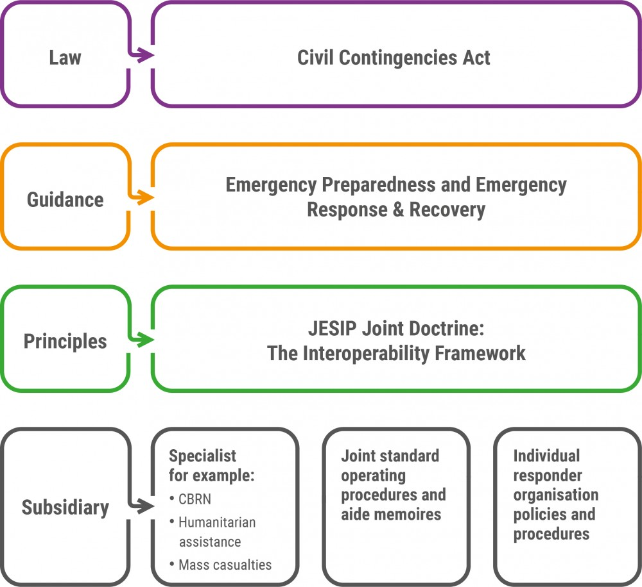

Metadata
classic-editor-remember | block-editor
header_slider
section_bottom | [section-appandnews]
custom_css
custom_js
backup_field

