Why do we need JESIP?
Author | admin
Date | 2022-03-15 08:45:08
Categories
The UK’s responder organisations are admired and respected all around the world for the excellent service they provide working to keep our country safe and secure as well protecting the public.
However, in our ever changing world they have to adapt to the demands placed upon them. This means they are working together, responding to emergencies on an ever increasing basis.

Drivers for Change
The findings from a number of reviews of major national emergencies and disasters made clear that the emergency services carry out their individual roles efficiently and professionally.
JESIP commissioned a review of the all the major incidents since 1986 to 2010 to identify recurring issues that contributed to this lack of interoperability. These were incidents where a public inquiry was held to determine the cause of failures, and as such provided a rich base of evidence. The findings of this review can be found in the Pollock Report.
To address the findings, JESIP developed some key solutions:
- The Joint Doctrine: The Interoperability Framework , now on it's Third Edition. This provides the foundation for all responder organisation multi-agency working in the UK and provides a set of common models and principles to help achieve interoperability.
- JOL Online - TheJoint Organisational Learning (JOL) Online tool is a web-based platform hosted within ResilienceDirect (RD). It is there for responder organisations to share their lessons and notable practice from testing, training, exercising and incident debriefs.
- Various supporting documents including M/ETHANE templates, an exercise assurance framework, exercise umpire template and many more which are available in the Downloads section.
- Joint training and awareness products. JESIP, working with key partners across the country, developed a number of training products to help responder organisations embed the interoperability principles. This ensures that the Joint Doctrine was, and continues to be, delivered consistently. These include:
- JESIP Multi-agency Interoperability Training Course - a combined one-day facilitated course for Control Room staff and Commanders.
- JESIP awareness presentation - a short presentation to enable awareness of JESIP to be delivered to all staff.
- E-learning - an e-learning package to improve awareness across all responder organisations.
- Films - a number of animated films to highlight key elements of JESIP, specifically including the use of M/ETHANE
- Mobile application - an interactive aide memoire to ensure responders always have key JESIP information at their fingertips.

The Pollock Report
Early in the programme, JESIP commissioned the Cabinet Office Emergency Planning College to research the persistent lessons identified relating to interoperability so we could gain an understanding of the issues. The outcome of this research was the Pollock Report, which can be downloaded by clicking on the image to the right.
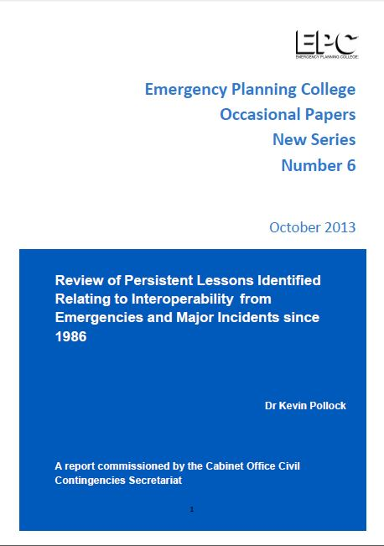

Related download

The Pollock Report
Last updated: Oct 2013
This report was commissioned to identify persistent issues that affect emergency responder interoperability as they ...
View download

Metadata
classic-editor-remember | block-editor
header_slider
section_bottom | [section-appandnews]
custom_css
custom_js
backup_field

